Atlas Bible College
2022-2023 Program Schedule

This schedule includes the weekly meeting dates, meeting times, reading assignments, lecture topics, and video assignments for 2022 – 2023.
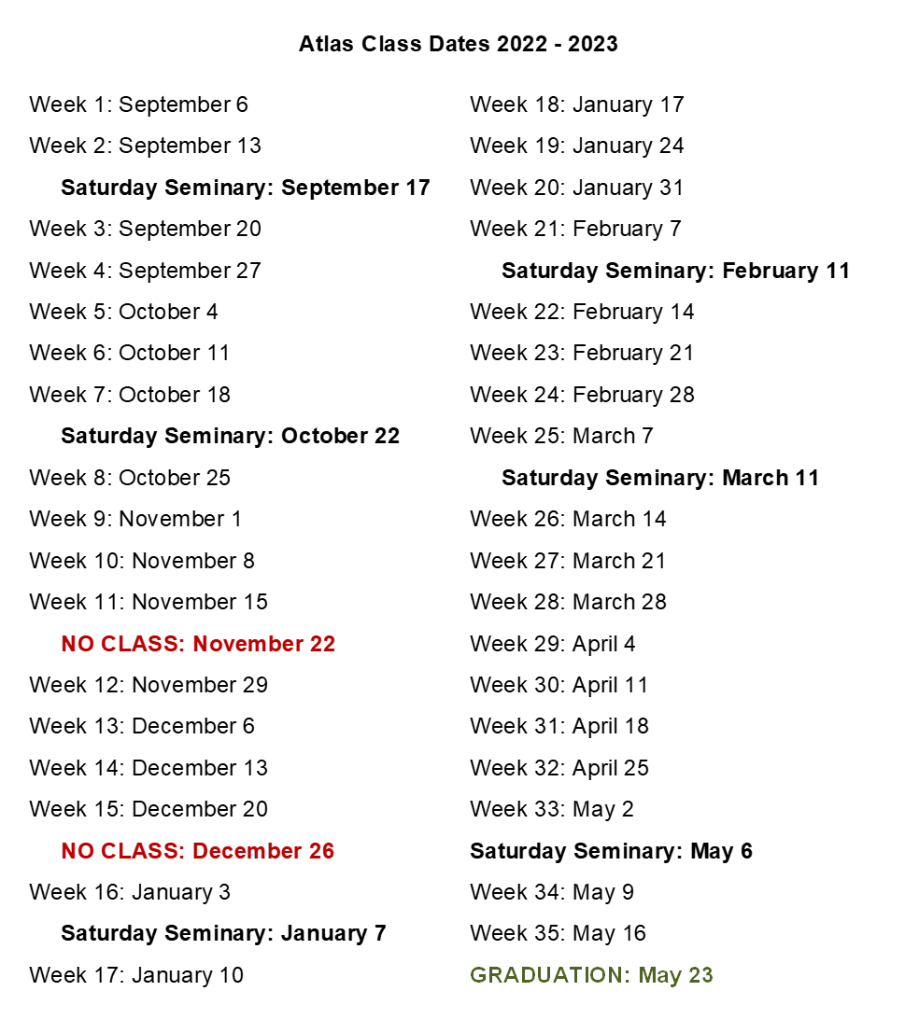
Intensive Schedule

Atlas Intensives (Saturday Seminaries)
These Seminaries are a Required Part of the Atlas Curriculum
September 17 ------------ | The Bible
October 22 ---------------- | Building a Faith that Flourishes in an Adversarial World
January 7 ------------------ | Early Christianity
February 11 --------------- | The Church: From The Reformation to Today
March 11 ------------------- | Pastoral Ethics
May 6 ----------------------- | Christianity Amongst Other Religions

Weekly Course Schedule

Week 1: September 6 - 12
Class: September 6
Time: 6PM – 9PM
Lecture: The Mythical Worldview
Reading:
- Genesis 1-32
- Encountering the Old Testament: Chapters 1, 2, 3, & 4.
- Called to Worship: Chapters 1 and 2
- The Seventh Key: Key One
Videos:
- Old Testament Overview (13 min) https://youtu.be/ALsluAKBZ-c
- Genesis 1-11 (8 min) https://youtu.be/GQI72THyO5I
- Genesis 12-50 (8 min) https://youtu.be/F4isSyennFo

Monthly Spiritual Discipline:
- Spiritual Disciplines for the Christian Life: Chapter 1 (The Spiritual Disciplines)
- Study Guide: Lesson 1

Week 2: September 13 - 19
Class: September 13
Time: 6PM – 9PM
Lecture: Creation Narratives
Reading:
- Genesis 33-Exodus 26
- Introducing Christian Doctrine: 13
- Encountering the Old Testament: Chapters 5 & 6
- Called to Worship: Chapter 3
- The Seventh Key: Key Two
Videos:
- Exodus 1-18 (6 min) https://youtu.be/jH_aojNJM3E
- Exodus 19-40 (6 min) https://youtu.be/oNpTha80yyE

Monthly Spiritual Discipline:
- Spiritual Disciplines for the Christian Life: Chapter 1 (The Spiritual Disciplines)
- Study Guide: Lesson 1

Week 3: September 20 - 26
Class: September 20
Time: 6PM – 9PM
Lecture: Imago Dei
Reading:
- Exodus 27- Numbers 4
- Introducing Christian Doctrine: 18
- Encountering the Old Testament: Chapter 7.
- Called to Worship: Chapter 4
- The Seventh Key: Key Three
Videos:
- OT Laws & Their Modern Application (9 min) https://youtu.be/56E8Ny49jGs
- OT Laws & New Testament Ethics (4 min) https://youtu.be/yLW7x8kR_Lw
- Leviticus (8 min) https://youtu.be/IJ-FekWUZzE
- Numbers (7 min) https://youtu.be/tp5MIrMZFqo

Monthly Spiritual Discipline:
- Spiritual Disciplines for the Christian Life: Chapter 1 (The Spiritual Disciplines)
- Study Guide: Lesson 1

Week 4: September 27 - October 3
Class: September 27
Time: 6PM – 9PM
Lecture: Bible Genres & How To Read Them
Reading:
- Numbers 5- Deuteronomy 13
- Encountering the Old Testament: Chapters 8 & 9.
- Called to Worship: Chapters 5 & 6
- The Seventh Key: Key Four
Videos:
- Bible Translations (7 min) https://youtu.be/EwrxWIgNYZQ
- Deuteronomy (8 min) https://youtu.be/q5QEH9bH8AU

Monthly Spiritual Discipline:
- Spiritual Disciplines for the Christian Life: Chapter 1 (The Spiritual Disciplines)
- Study Guide: Lesson 1

Week 5: October 4 - 10
Class: October 4
Time: 6PM – 9PM
Lecture: Hermeneutics Rules & Common Fallacies
Reading:
- Deuteronomy 14- Joshua 24
- Encountering the Old Testament: Chapters 10 & 11
- Called to Worship: Chapter 7
- The Seventh Key: Key Five
Videos:
- The Godly Steward (22 min) https://youtu.be/HF0J9E-NGdg
- Joshua (9 min) https://youtu.be/JqOqJlFF_eU

Monthly Spiritual Discipline:
- Spiritual Disciplines for the Christian Life: Chapters 2 & 3 (Bible Intake Part 1 & 2)
- Study Guide: Lessons 2 & 3

Week 6: October 11 - 17
Class: October 11
Time: 6PM – 9PM
Lectures: Covenants & Interpretive Frameworks
Reading:
- Judges 1- 1 Samuel 25
- Encountering the Old Testament: Chapters 12 & 13
- Called to Worship: Chapter 8
- The Seventh Key: Key Six
Videos:
- Judges (7 min) https://youtu.be/kOYy8iCfIJ4
- Ruth (7 min) https://youtu.be/0h1eoBeR4Jk
- 1 Samuel (7 min) https://youtu.be/QJOju5Dw0V0

Monthly Spiritual Discipline:
- Spiritual Disciplines for the Christian Life: Chapters 2 & 3 (Bible Intake Part 1 & 2)
- Study Guide: Lessons 2 & 3

Week 7: October 18 - 24
Class: October 18
Time: 6PM – 9PM
Lecture: Doctrine of God (1)
Reading:
- 1 Samuel 26- 1 Kings 15
- Introducing Christian Doctrine: Chapters 8 & 11
- Encountering the Old Testament: Chapters 14 & 15
- Called to Worship: Chapter 9
- The Seventh Key: Key Seven
Videos:
- 2 Samuel (6 min) https://youtu.be/YvoWDXNDJgs
- 1 & 2 Kings (9 min) https://youtu.be/bVFW3wbi9pk

Monthly Spiritual Discipline:
- Spiritual Disciplines for the Christian Life: Chapters 2 & 3 (Bible Intake Part 1 & 2)
- Study Guide: Lessons 2 & 3

Week 8: October 25 - 31
Class: October 25
Time: 6PM – 9PM
Lecture: Doctrine of God (2)
Reading
- 1 Kings 16- 1 Chronicles 13
- Introducing Christian Doctrine:
- Chapters 9 & 10
- Encountering the Old Testament: Chapter 16
- Called to Worship: Chapter 10
Videos
- What Was The Reformation All About? (3 min) https://youtu.be/Qd97uoZIqXI
- The Gospel Before the Reformation (5 min) https://youtu.be/oYajBc_h7PE
- Chronicles (6 min) https://youtu.be/HR7xaHv3Ias

Monthly Spiritual Discipline:
- Spiritual Disciplines for the Christian Life: Chapters 2 & 3 (Bible Intake Part 1 & 2)
- Study Guide: Lessons 2 & 3

Week 9: November 1- 7
Class: November 1
Time: 6PM – 9PM
Lecture: Doctrine of God (3)
Reading:
- 1 Chronicles 14- 2 Chronicles 30
- Introducing Christian Doctrine: Chapters 12 & 14
- Encountering the Old Testament: Chapter 17

Monthly Spiritual Discipline:
- Spiritual Disciplines for the Christian Life: Chapter 4 (Prayer)
- Study Guide: Lesson 4

Week 10: November 8 -14
Class: November 8
Time: 6PM – 9PM
Lecture: Sabbath
Reading:
- 2 Chronicles 31- Esther 10
- Encountering the Old Testament: Chapter 18
- Called to Worship: Chapter 11
Videos:
- Ezra-Nehemiah (8 min) https://youtu.be/MkETkRv9tG8
- Esther (9 min) https://youtu.be/JydNSlufRIs

Monthly Spiritual Discipline:
- Spiritual Disciplines for the Christian Life: Chapter 4 (Prayer)
- Study Guide: Lesson 4

Week 11: November 15 - 21
Class: November 15
Time: 6PM – 9PM
Lecture: The Church Calendar & Holidays
Reading:
- Job
Monthly Spiritual Discipline:
- Spiritual Disciplines for the Christian Life: Chapter 4 (Prayer)
- Study Guide: Lesson 4

Thanksgiving Break: November 22-28

Week 12: November 29 - December 5
Class: November 29
Time: 6PM – 9PM
Lecture: Doctrine of Man & Salvation (1)
Reading:
- Psalm 1-45
- Introducing Christian Doctrine: Chapters 17 & 19
- Encountering the Old Testament: Chapters 19 & 20
Videos:
- Job (11 min) https://youtu.be/xQwnH8th_fs
- Psalms (9 min) https://youtu.be/j9phNEaPrv8

Monthly Spiritual Discipline:
- Spiritual Disciplines for the Christian Life: Chapter 5 (Worship)
- Study Guide: Lesson 5

Week 13: December 6 -12
Class: December 6
Time: 6PM – 9PM
Lecture: Doctrine of Man & Salvation (2)
Reading:
- Psalm 46-90
- Introducing Christian Doctrine: Chapters 20, 21, & 22
- Encountering the Old Testament: Chapter 21
- Called to Worship: Chapter 12
Videos:
- Should Christians Celebrate Christmas? (3 min) https://youtu.be/W-qnRII5QZ0

Monthly Spiritual Discipline:
- Spiritual Disciplines for the Christian Life: Chapter 5 (Worship)
- Study Guide: Lesson 5

Week 14: December 13 -19
Class: December 13
Time: 6PM – 9PM
Lecture: Doctrine of Man & Salvation (3)
Reading:
- Psalm 91-119
- Introducing Christian Doctrine: Chapters 31, 32, 33, 34, & 35
- Encountering the Old Testament: Chapter 22
Videos:
- What We Celebrate at Christmas (5 min) https://youtu.be/oejq25JYhLQ
- Proverbs (8 min) https://youtu.be/AzmYV8GNAIM

Monthly Spiritual Discipline:
- Spiritual Disciplines for the Christian Life: Chapter 5 (Worship)
- Study Guide: Lesson 5

Week 15: December 20 - 20
Class: December 20
Time: 6PM – 9PM
Lecture: Denominations (There May Be Christmas Treats!)
Reading:
- Psalm 120-150, Proverbs 1-31
- No Other Reading Or Homework

Monthly Spiritual Discipline:
- Spiritual Disciplines for the Christian Life: Chapter 5 (Worship)
- Study Guide: Lesson 5

Christmas Break: December 21 – January 2

Week 16: January 3 - 9
Class: January 3
Time: 6PM – 9PM
Lecture: Branches & Types of Theology
Reading:
- Ecclesiastes & Song of Solomon
- Encountering the Old Testament: Chapter 23
- Called to Worship: Chapters 13 & 14
Videos:
- Ecclesiastes (8 min) https://youtu.be/lrsQ1tc-2wk
- Song of Songs (7 min) https://youtu.be/4KC7xE4fgOw

Monthly Spiritual Discipline:
- Spiritual Disciplines for the Christian Life: Chapter 6 (Evangelism)
- Study Guide: Lesson 6

Week 17: January 10 - 16
Class: January 10
Time: 6PM – 9PM
Lecture: Doctrine of Christ (1)
Reading:
- Isaiah 1-45
- Introducing Christian Doctrine: Chapters 23, 24, & 25
- Encountering the Old Testament: Chapters 24 & 25
- Called to Worship: Chapter 15
Videos:
- Thinking About Jesus Christ (14 min) https://youtu.be/VHHQ1EfifJ0
- Isaiah 1-39 (8 min) https://youtu.be/d0A6Uchb1F8

Monthly Spiritual Discipline:
- Spiritual Disciplines for the Christian Life: Chapter 6 (Evangelism)
- Study Guide: Lesson 6

Week 18: January 17 - 23
Class: January 17
Time: 6PM – 9PM
Lecture: Doctrine of Christ (2)
Reading:
- Isaiah 46- Jeremiah 43
- Introducing Christian Doctrine: Chapters 26 & 27
- Encountering the Old Testament: Chapters 26 & 27
Videos:
- Isaiah 40-66 (8 min) https://youtu.be/_TzdEPuqgQg
- Jeremiah (7 min) https://youtu.be/RSK36cHbrk0

Monthly Spiritual Discipline:
- Spiritual Disciplines for the Christian Life: Chapter 6 (Evangelism)
- Study Guide: Lesson 6

Week 19: January 24 - 30
Class: January 24
Time: 6PM – 9PM
Lecture: Doctrine of Christ (3)
Reading:
- Jeremiah 44- Ezekiel 48
- Encountering the Old Testament: Chapters 28, 29, & 30
Videos:
- Lamentations (7 min) https://youtu.be/p8GDFPdaQZQ
- Ezekiel 1-33 (7 min) https://youtu.be/R-CIPu1nko8
- Ezekiel 34-48 (7 min) https://youtu.be/SDeCWW_Bnyw

Monthly Spiritual Discipline:
- Spiritual Disciplines for the Christian Life: Chapter 6 (Evangelism)
- Study Guide: Lesson 6

Week 20: January 31- February 6
Class: January 31
Time: 6PM – 9PM
Lecture: Heaven & Hell
Reading:
- Daniel 1- Malachi 4
- Introducing Christian Doctrine: Chapter 42
- Encountering the Old Testament: Chapters 31, 32, 33, and 34
- Called To Worship: Chapter 21
Videos:
- Daniel (9 min) https://youtu.be/9cSC9uobtPM
- Hosea (7 min) https://youtu.be/kE6SZ1ogOVU
- Joel (7 min) https://youtu.be/zQLazbgz90c
- Amos (7 min) https://youtu.be/mGgWaPGpGz4
- Obadiah (5 min) https://youtu.be/i4ogCrEoG5s
- Jonah (9 min) https://youtu.be/dLIabZc0O4c
- Micah (7 min) https://youtu.be/MFEUEcylwLc
- Nahum (5 min) https://youtu.be/Y30DanA5EhU
- Habakkuk (7 min) https://youtu.be/OPMaRqGJPUU
- Zephaniah (5 min) https://youtu.be/oFZknKPNvz8
- Haggai (5 min) https://youtu.be/juPvv_xcX-U
- Zechariah (8 min) https://youtu.be/_106IfO6Kc0
- Malachi (7 min) https://youtu.be/HPGShWZ4Jvk

Monthly Spiritual Discipline:
- Spiritual Disciplines for the Christian Life: Chapter 7 (Serving)
- Study Guide: Lesson 7

Week 21: February 7 - 13
Class: February 7
Time: 6PM – 9PM
Lecture: The Synoptic Problem
Reading:
- Matthew 1- Mark 16
- Encountering the New Testament: Chapters 3, 4, & 5
- Called to Worship: Chapter 16
Videos:
- Understanding Jesus’ Genealogy (8 min) https://youtu.be/TqN_S704_DE
- New Testament (8 min) https://youtu.be/Q0BrP8bqj0c
- Matthew 1-13 (8 min) https://youtu.be/3Dv4-n6OYGI
- Matthew 14-28 (7 min) https://youtu.be/GGCF3OPWN14
- Mark (9 min) https://youtu.be/HGHqu9-DtXk

Monthly Spiritual Discipline:
- Spiritual Disciplines for the Christian Life: Chapter 7 (Serving)
- Study Guide: Lesson 7

Week 22: February 14 - 20
Class: February 14
Time: 6PM – 9PM
Lecture: Baptism
Reading:
- Luke
- Encountering the New Testament: Chapters 6 & 8
- Called to Worship: Chapter 17
Videos:
- Luke 1-9 (8 min) https://youtu.be/XIb_dCIxzr0
- Luke 10-24 (8 min) https://youtu.be/26z_KhwNdD8

Monthly Spiritual Discipline:
- Spiritual Disciplines for the Christian Life: Chapter 7 (Serving)
- Study Guide: Lesson 7

Week 23: February 21 - 27
Class: February 21
Time: 6PM – 9PM
Lecture: The Lord’s Supper
Reading:
- John
- Encountering the New Testament: Chapters 7 & 9
Videos:
- John 1-12 (9 min) https://youtu.be/G-2e9mMf7E8
- John 13-21 (8 min) https://youtu.be/RUfh_wOsauk

Monthly Spiritual Discipline:
- Spiritual Disciplines for the Christian Life: Chapter 7 (Serving)
- Study Guide: Lesson 7

Week 24: February 28 - March 6
Class: February 28
Time: 6PM – 9PM
Lecture: Acts / New Testament Ministry / Early Church
Reading:
- Acts 1-14
- Encountering the New Testament: Chapters 13, 14, & 15
Videos:
- Pentecost (11 min) https://youtu.be/2U2sk-POYC4
- Who is the Holy Spirit? 3 min https://youtu.be/yBz8hJoeuoA
- Acts 1-12 (8 min) https://youtu.be/CGbNw855ksw

Monthly Spiritual Discipline:
- Spiritual Disciplines for the Christian Life: Chapter 8 (Stewardship)
- Study Guide: Lesson 8

Week 25: March 7 - March 13
Class: March 7
Time: 6PM – 9PM
Lecture: History of Worship
Reading:
- Acts 15-28
- Encountering the New Testament: Chapter 16
- Called to Worship: Chapter 18
Videos:
- Acts 13-28 (8 min) https://youtu.be/Z-17KxpjL0Q
- Evolution of Worship Music- A Cappella Medley (8 min) https://youtu.be/2SaBhN2idbM

Monthly Spiritual Discipline:
- Spiritual Disciplines for the Christian Life: Chapter 8 (Stewardship)
- Study Guide: Lesson 8

Week 26: March 14 - March 20
Class: March 14
Time: 6PM – 9PM
Lecture: Doctrine of Holy Spirit & Angels (1)
Reading:
- Romans 1-12
- Introducing Christian Doctrine: Chapter 28
- Encountering the New Testament: Chapters 17 & 18
Videos:
- Romans 1-4 (8 min) https://youtu.be/ej_6dVdJSIU
- Romans 5-16 (9 min) https://youtu.be/0SVTl4Xa5fY

Monthly Spiritual Discipline:
- Spiritual Disciplines for the Christian Life: Chapter 8 (Stewardship)
- Study Guide: Lesson 8

Week 27: March 21 - 27
Class: March 21
Time: 6PM – 9PM
Lecture: Doctrine of Holy Spirit & Angels (2)
Reading:
- 1 & 2 Corinthians
- Introducing Christian Doctrine: Chapters 29 & 30
- Encountering the New Testament: Chapter 19
- Called to Worship: Chapter 19
Videos:
- When The Perfect Comes (13 min) https://youtu.be/_NfxoXXFxdo
- 1 Corinthians (9 min) https://youtu.be/yiHf8klCCc4
- 2 Corinthians (8 min) https://youtu.be/3lfPK2vfC54

Monthly Spiritual Discipline:
- Spiritual Disciplines for the Christian Life: Chapter 8 (Stewardship)
- Study Guide: Lesson 8

Week 28: March 28 - April 3
Class: March 28
Time: 6PM – 9PM
Lecture: Doctrine of Holy Spirit & Angels (3)
Reading:
- Galatians 1- Colossians 4
- Introducing Christian Doctrine: Chapter 16
- Encountering the New Testament: Chapters 20 & 21
- Called to Worship: Chapter 20
Videos:
- Galatians (9 min) https://youtu.be/vmx4UjRFp0M
- Ephesians (9 min) https://youtu.be/Y71r-T98E2Q
- Philippians (9 min) https://youtu.be/oE9qqW1-BkU
- Colossians (9 min) https://youtu.be/pXTXlDxQsvc

Monthly Spiritual Discipline:
- Spiritual Disciplines for the Christian Life: Chapters 9 & 10 (Fasting, Silence & Solitude)
- Study Guide: Lesson 9

Week 29: April 4 - April 10
Class: April 4
Time: 6PM – 9PM
Lecture: Men & Women in Ministry
Reading:
- 1 Thessalonians- Titus 4
No Other Reading Or Homework

Monthly Spiritual Discipline:
- Spiritual Disciplines for the Christian Life: Chapters 9 & 10 (Fasting, Silence & Solitude)
- Study Guide: Lesson 9

EASTER - EASTER - EASTER - EASTER - EASTER

Week 30: April 11- April 17
Class: April 11
Time: 6PM – 9PM
Lecture: Theology of Suffering/Persecution
Reading:
- Philemon & Hebrews
- Encountering the New Testament: Chapter 22
Videos:
- Blessings from Suffering (4 min) https://youtu.be/pV8PJ7WL6Tw
- Think Christianly (14 min) https://youtu.be/jESqfjqPMHE
- 1 Thessalonians (7 min) https://youtu.be/No7Nq6IX23c
- 2 Thessalonians (7 min) https://youtu.be/kbPBDKOn1cc
- 1 Timothy (9 min) https://youtu.be/7RoqnGcEjcs
- 2 Timothy (8 min) https://youtu.be/urlvnxCaL00
- Titus (8 min) https://youtu.be/PUEYCVXJM3k
- Philemon (6 min) https://youtu.be/aW9Q3Jt6Yvk
- Hebrews (8 min) https://youtu.be/1fNWTZZwgbs

Monthly Spiritual Discipline:
- Spiritual Disciplines for the Christian Life: Chapters 9 & 10 (Fasting, Silence & Solitude)
- Study Guide: Lesson 9

Week 31: April 18 - 24
Class: April 18
Time: 6PM – 9PM
Lecture: The Priesthood of All Believers
Reading:
- James 1- Jude
- Encountering the New Testament: Chapter 23
Videos:
- James (8 min) https://youtu.be/qn-hLHWwRYY
- 1 Peter (8 min) https://youtu.be/WhP7AZQlzCg
- 2 Peter (8 min) https://youtu.be/wWLv_ITyKYc
- 1-3 John (9 min) https://youtu.be/l3QkE6nKylM
- Jude (8 min) https://youtu.be/6UoCmakZmys

Monthly Spiritual Discipline:
- Spiritual Disciplines for the Christian Life: Chapters 9 & 10 (Fasting, Silence & Solitude)
- Study Guide: Lesson 9

Week 32: April 25 - May 1
Class: April 25
Time: 6PM – 9PM
Lecture: Eschatology & End Times Views
Reading:
- Revelation
- Introducing Christian Doctrine: Chapter 39, 40, & 41
- Encountering the New Testament: Chapter 24
Videos:
- What Should Christians Believe About The End Times? (2 min) https://youtu.be/SVjKgn-Ed4I
- Revelation 1-11 (12 min) https://youtu.be/5nvVVcYD-0w
- Revelation 12-22 (12 min) https://youtu.be/QpnIrbq2bKo

Monthly Spiritual Discipline:
- Spiritual Disciplines for the Christian Life: Chapters 11, 12, & 13 (Journaling, Learning, & Perseverance in the Disciplines)
- Study Guide: Lesson 10

Week 33: May 2 - 8
Class: May 2
Time: 6PM – 9PM
Lecture: Spiritual Disciplines
Reading:
- Catch Up On Missed Reading
Videos:
- The Role of the Holy Spirit in Spiritual Disciplines (3 min) https://youtu.be/Umsz34OmK2U

Monthly Spiritual Discipline:
- Spiritual Disciplines for the Christian Life: Chapters 11, 12, & 13 (Journaling, Learning, & Perseverance in the Disciplines)
- Study Guide: Lesson 10

Week 34: May 9 - 15
Class: May 9
Time: 6PM – 9PM
Lecture: One Kingdom Theology
Reading:
- Catch Up On Missed Reading
Videos:
- From Two Kingdom to One Kingdom Living (40 min) https://youtu.be/5zk7qam3kWQ

Monthly Spiritual Discipline:
- Spiritual Disciplines for the Christian Life: Chapters 11, 12, & 13 (Journaling, Learning, & Perseverance in the Disciplines)
- Study Guide: Lesson 10

Week 35: May 16 - 22
Class: May 16
Time: 6PM – 9PM
Lecture: Final Exam (6PM)
Missio Dei (7PM)
Closing Thoughts (8PM)
Reading:
- Catch Up On Missed Reading

Monthly Spiritual Discipline:
- Spiritual Disciplines for the Christian Life: Chapters 11, 12, & 13 (Journaling, Learning, & Perseverance in the Disciplines)
- Study Guide: Lesson 10

GRADUATION: May 23, 2023
Time and Location TBD

